**Experiment-6**

Create a simple cloud software application for Payroll Processing System using any Cloud Service Provider to demonstrate SaaS include the necessary fields such as Name of the employee, experience in present org , over all experience, basic pay, HRA, DA, TA, net pay, gross pay etc.

**Implementation:**

**STEP 01:**

Open a Zoho web application and click a Create a New application and Create a New Component And select a Component Type as Form Type.

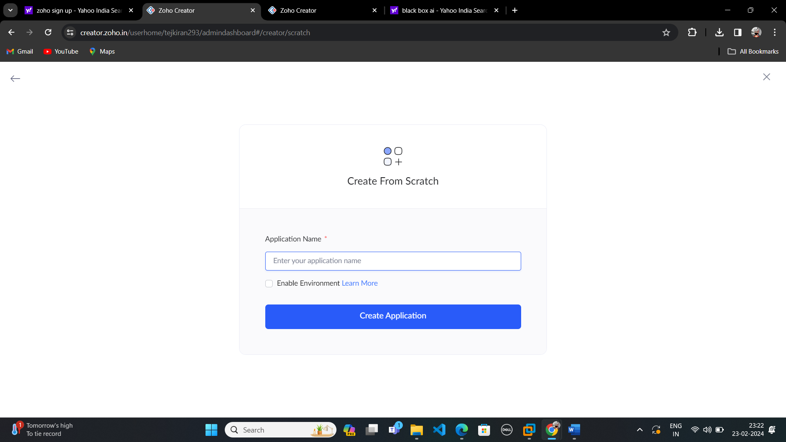

**STEP:02**

Start To a Create a Form from Scratch

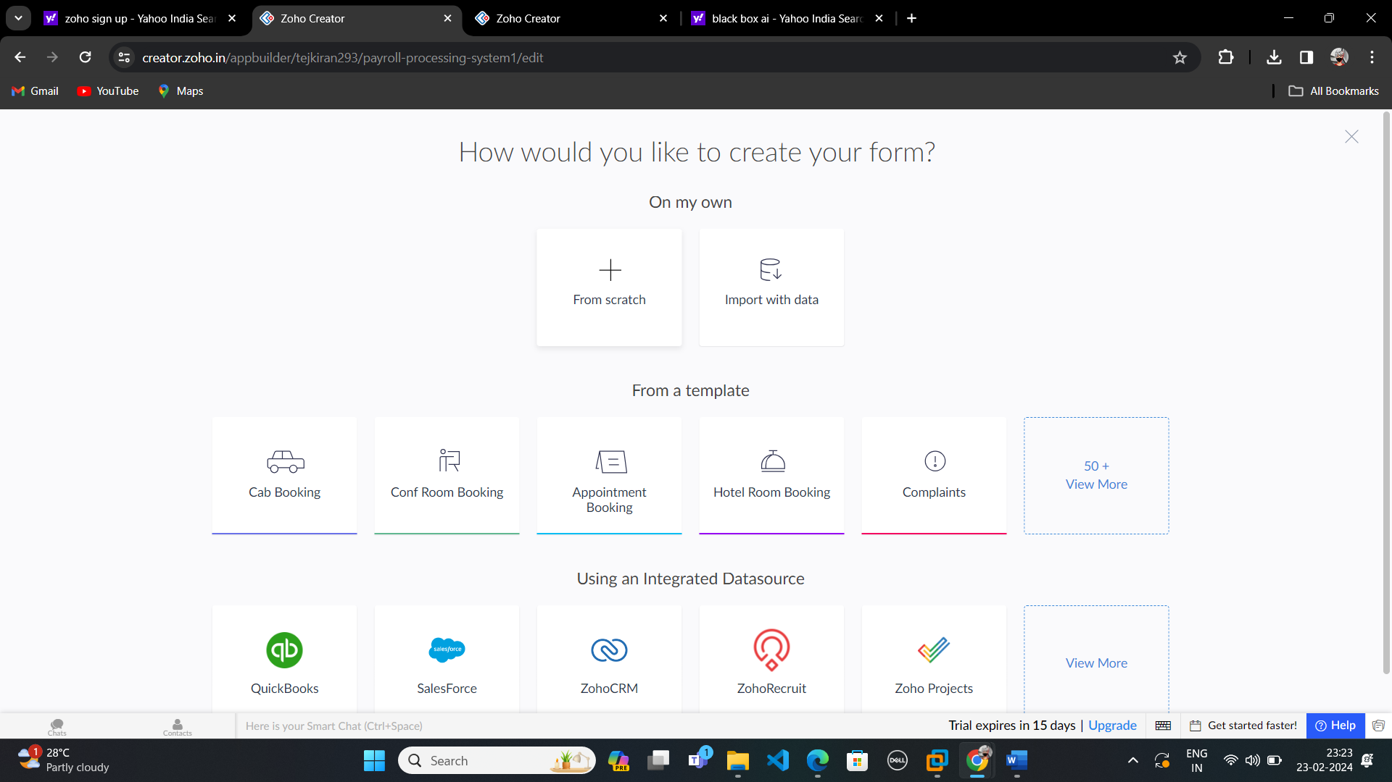

**STEP 03:**

To Give a Name For Your Form and click a Button Create From Scratch

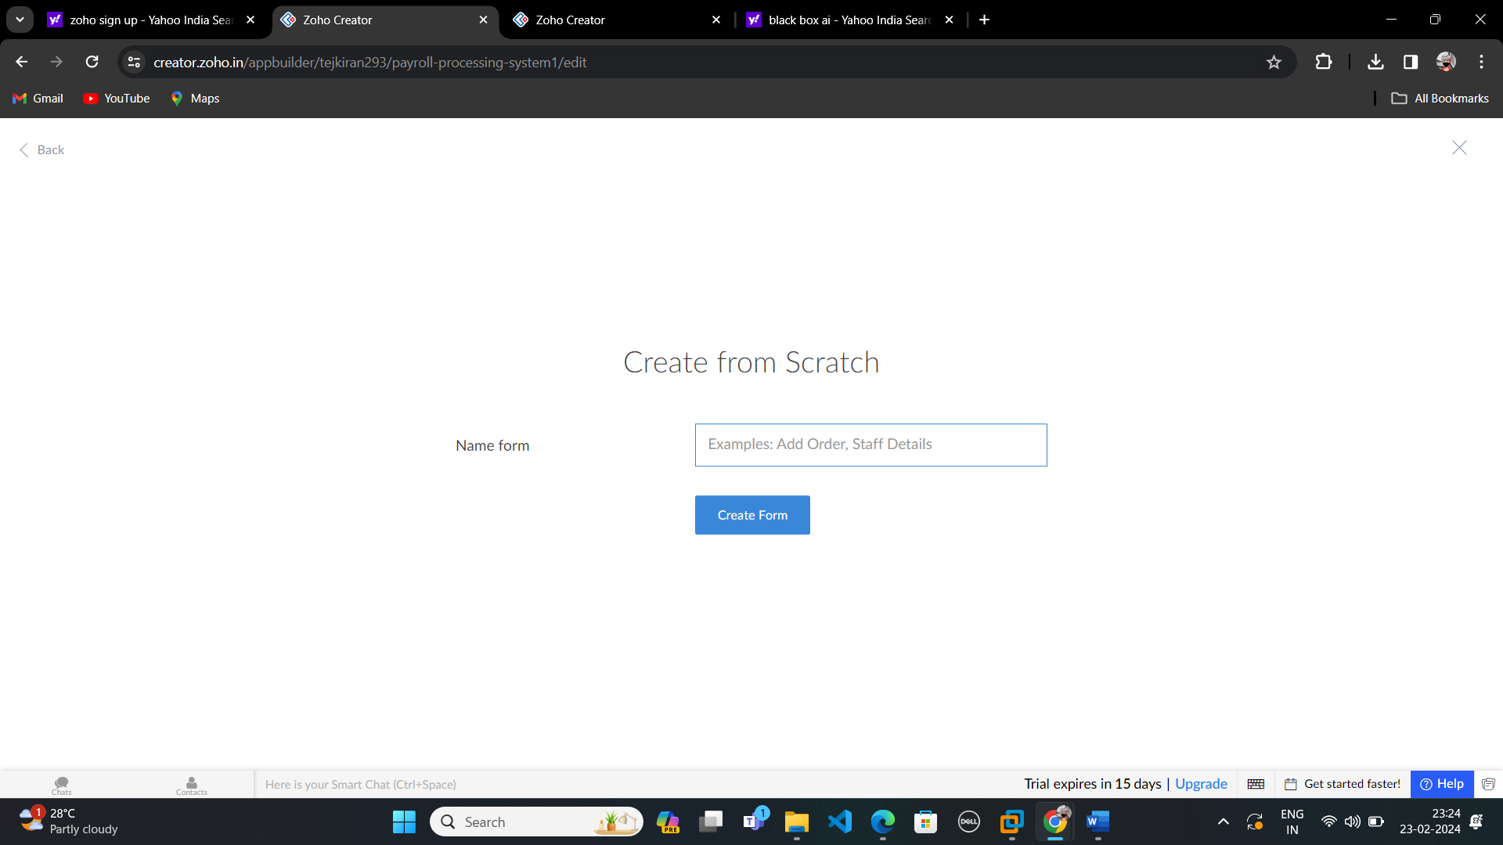

**STEP 04:**

Create Employee details form and edit the form.

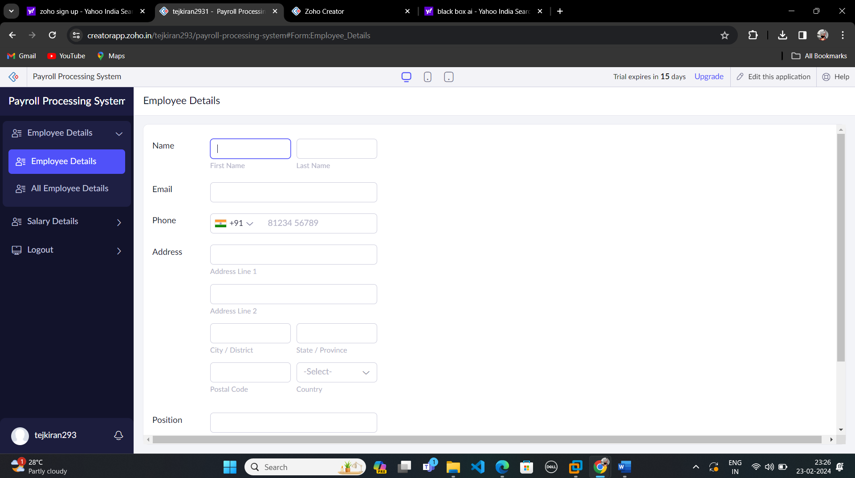

**STEP-5:**

After Finishing that Create another form for your application by clicking a Add icon and Edit that form.

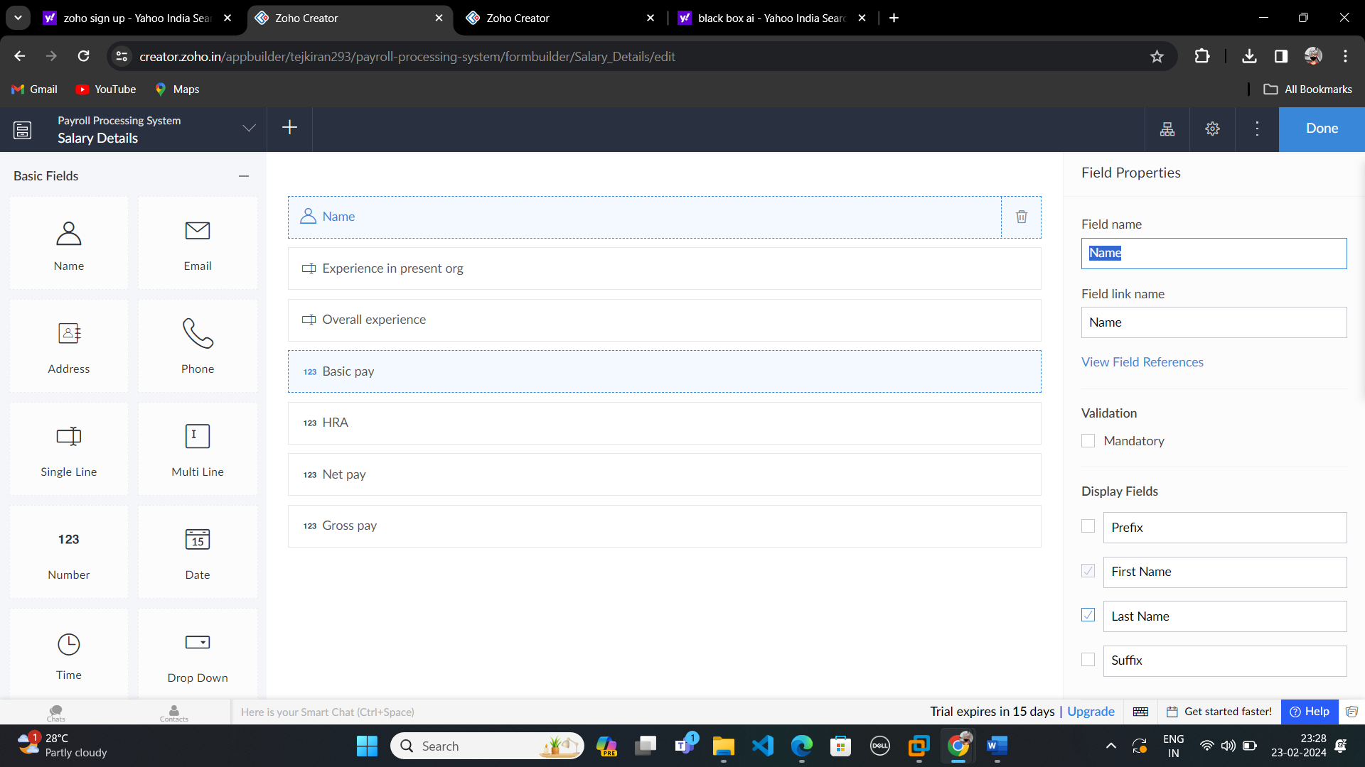

**STEP-06:**

After Finish the Edit Process click Done And then Open the View page.

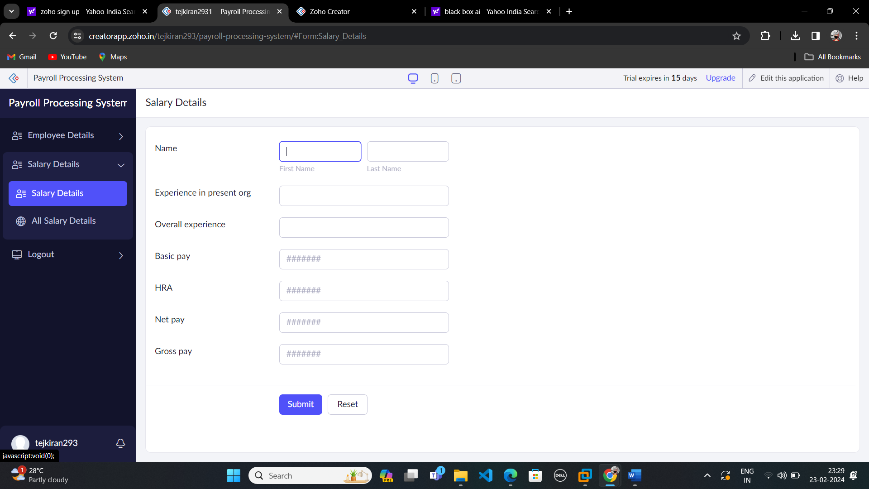

**Step-07:**

After Finishing that Create another form for your application by clicking a Add icon and Edit that form.

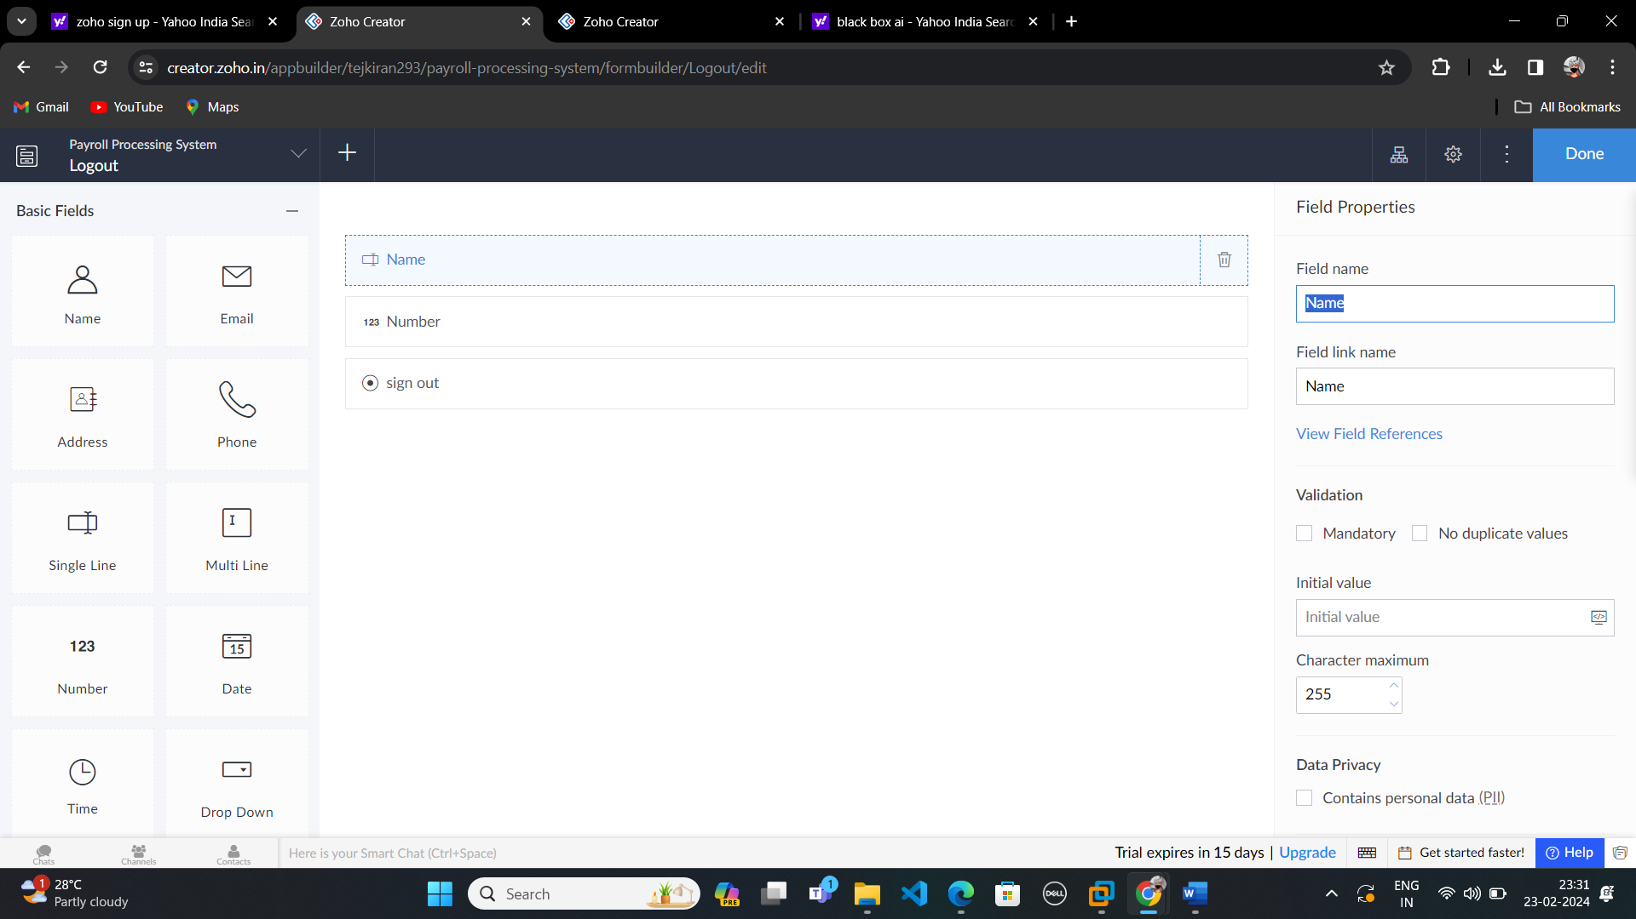

**Step-08:**

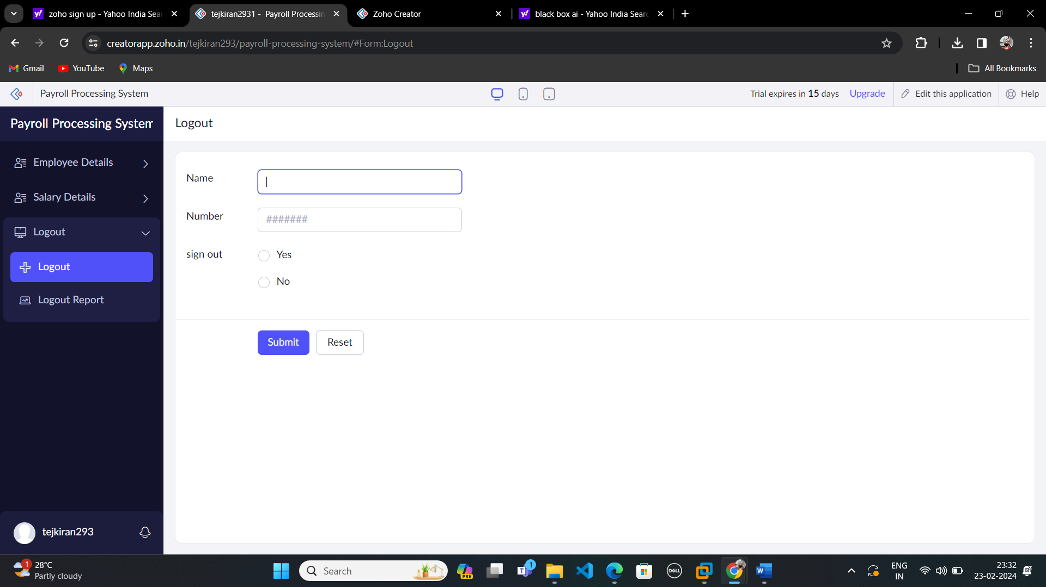

**Step-09:**

After Finish the Edit Process click Done And then Open the View page.

